Sri Lanka Institute of Information
Technology

Lab Submission
Lab sheet No 10

IT24200536
Karunarathna B.G.C.N.S.

IT2120 - Probability and Statistics
B.Sc. (Hons) in Information Technology

Question 1
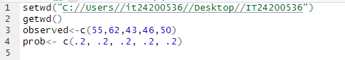

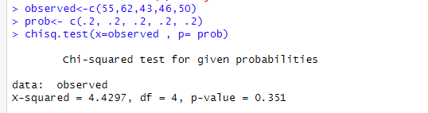
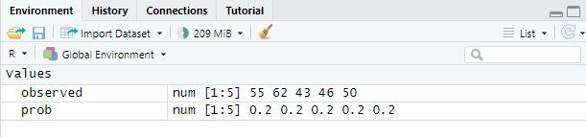
Question 2
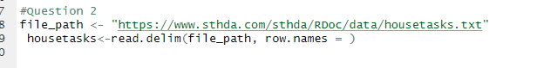
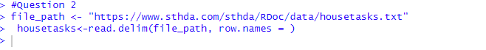
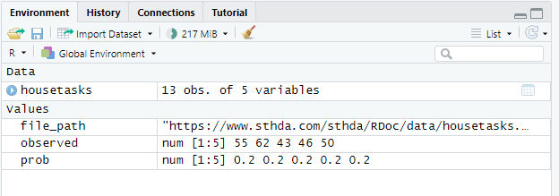
Exercise
